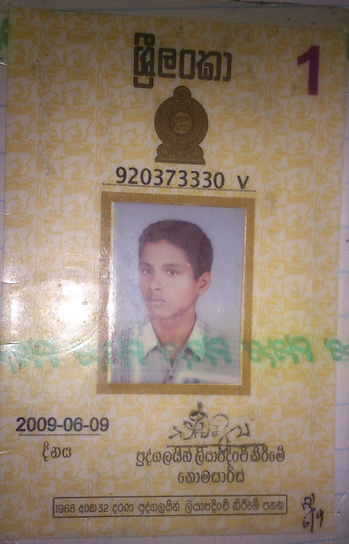

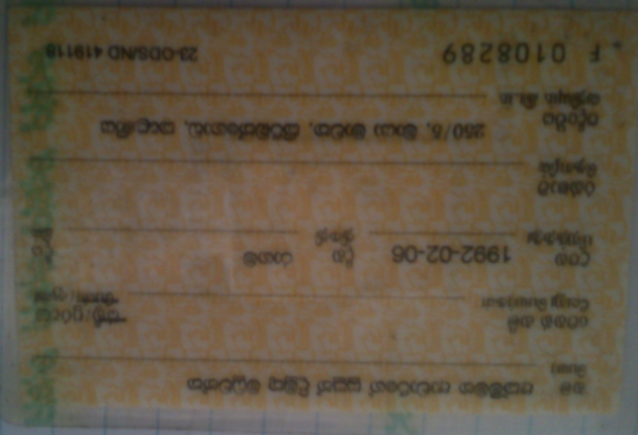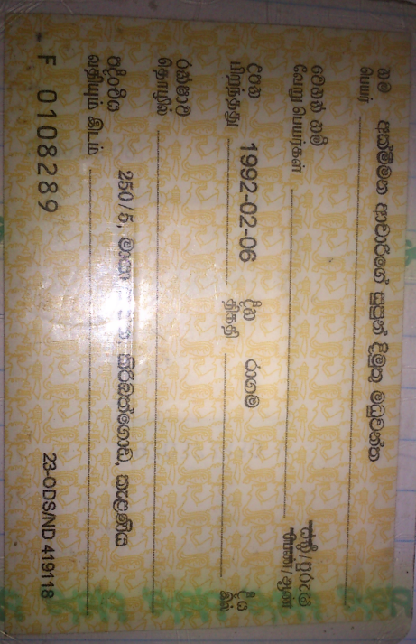



SW2 - DATA POSTPAY

0725918128



SW2 - DATA POSTPAY

0725918129

**Akmeemana Aacharige Supun Dimuthu Maduwantha.**

**0715918128.**

**250/5 Maya mawatha, Kiribathgoda, Kalaniya.**

**920373330v**